Laboratory Skills Assessment Name ____________________________________
Chemistry Date _________________________
Mrs. Booth Class Period ______

- Several statements are printed in column I of the table concerning students’ activities and attitudes in the lab. Think about each statement and formulate a safety rule or procedure related to each statement. Write one or two clear sentences in Column II that can serve as a safety policy for the classroom.
Column I | Column II
Austin says that his teacher is solely responsible for preventing laboratory accidents.
Daniel started the lab activity before reading it through completely.
Logan decided to do a lab activity that he read in a library book before the teacher came into the classroom.
Holly says that the lab aprons are unattractive and that the safety goggles mess up her hair. She refuses to wear them.

- Describe the location and purpose of having each of the following safety devices in our classroom.
Safety Device | Location | Purpose
Fire Blanket
Fire Extinguisher
Goggles
Eyewash Station
Gas Shut Off Button

- The pictures below show students performing lab activities incorrectly. Study each picture and write in the space provided all improper lab techniques that are illustrated. Be prepared to explain why it is important to follow each safety procedure.
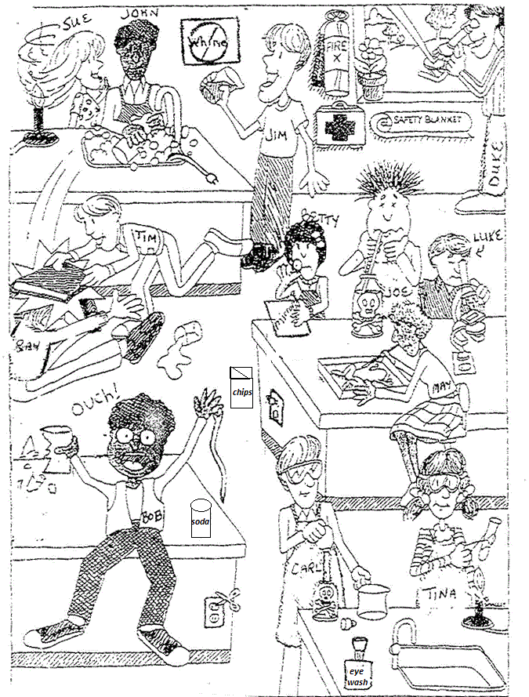
______________________________________________________________________________________________________________________________________________________________________________________________________________________________________________________________________________
______________________________________________________________________________________________________________________________________________________________________________________________________________________________________________________________________________
______________________________________________________________________________________________________________________________________________________________________________________________________________________________________________________________________________
______________________________________________________________________________________________________________________________________________________________________________________________________________________________________________________________________________
______________________________________________________________________________________________________________________________________________________________________________________________________________________________________________________________________________
- What is the proper way to handle each of the following situations?
  - A chemical is splashed into someone’s eyes.
______________________________________________________________________________________________________________________________________________________________________________________________________________________________________________________________________________
  - Concentrated hydrochloric acid is spilled onto your lab coat.
______________________________________________________________________________________________________________________________________________________________________________________________________________________________________________________________________________
  - You accidentally mix the wrong chemicals in a beaker.
______________________________________________________________________________________________________________________________________________________________________________________________________________________________________________________________________________

- What should you do before you mix any chemicals? _______________________________________ ________________________________________________________________________________________________________________________________________________________________________
- If you spill a chemical, what should you do? ______________________________________________ ________________________________________________________________________________________________________________________________________________________________________
- What should you do with the products or waste left over from an experiment? _________________ ________________________________________________________________________________________________________________________________________________________________________
- What type of shoes should you wear when doing an experiment? _____________________________
- How should you wear your hair when doing an experiment? ________________________________
- How should you protect your eyes and body when doing an experiment? _____________________ ____________________________________________________________________________________
- What should you do when you are finished with your experiment? ___________________________ ________________________________________________________________________________________________________________________________________________________________________

